**Smart Food Choice E-commerce**

An Undergraduate Capstone Project Proposal

Presented to the

Panel of Examiners

Cebu Technological University

TABOGON EXTENSION

Poblacion, Tabogon, Cebu

In Partial Fulfillment

Of the Requirements for the Degree

BACHELOR OF SCIENCE IN INFORMATION TECHNOLOGY

Alburo, Jolina S.

Baril, Vicente

Cabahug, Ervin

Quilaton, Francis John

Saladaga, Edrelyn

Subito, Loren

**Chapter I**

**THE PROBLEM AND ITS SCOPE**

**INTRODUCTION**

**Project Context**

In today’s fast-changing business environment, it’s extremely important to be able to respond to client needs in the most effective and timely manner. If your customers wish to see your business online and have instant access to your products or services.

Smart Food Choice is a lifestyle e-commerce web application, which retails various fashion and lifestyle products. This project allows viewing various products available enables registered users to purchase desired products using Cash on Delivery (Pay Later) option. This project provides an easy access to Administrators and Customers to view orders placed using Pay options. In order to develop an e-commerce website, a number of Technologies must be studied and understood. These include multi-tiered architecture, server and client-side scripting techniques, implementation technologies such as PHP, programming language and relational databases. This is a project with the objective to develop a basic website where a consumer is provided with a shopping cart application and also to know about the technologies used to develop such an application. This document will discuss each of the underlying technologies to create and implement an ecommerce website.

E-commerce is fast gaining ground as an accepted and used business paradigm. More and more business houses are implementing web sites providing functionality for performing commercial transactions over the web. It is reasonable to say that the process of shopping on the web is becoming commonplace.

The objective of this project is to develop a general-purpose e-commerce store where product like clothes can be bought from the comfort of home through the Internet. However, for implementation purposes, this paper will deal with an online shopping for clothes.

An online store is a virtual store on the Internet where customers can browse the catalog and select products of interest. The selected items may be collected in a shopping cart. At checkout time, the items in the shopping cart will be presented as an order. At that time, more information will be needed to complete the transaction. Usually, the customer will be asked to fill or select a billing address, a shipping address, a shipping option, and payment information such as credit card number. An e-mail notification is sent to the customer as soon as the order is placed.

**Purpose and Description of the Project**

The Smart Food Choice E-commerce is an online shop wherein the primary objective is to help the customers order online without going to the location of the store and decreasing their human efforts in transacting physically at the location.

The following are additional description of the project.

* Any member can register and view available products.
* Only registered member can purchase multiple products regardless of quantity.
* There are three roles available: Visitor, User and Admin.

• Visitor can view available products.

• User can view and purchase products.

* An Admin has some extra privilege including all privilege of visitor and user.
* Admin can add products, edit product information and add/remove product
* Admin can add user, edit user information and can remove user.

**General Objectives**

The main object of the Smart Food Choice E-commerce is to provide an easy way of ordering from online shop, to lessen the human effort of the customer in going anywhere looking for something to buy. With the proposed project, it will help the users to look for products with better qualities.

**Specific objectives**

* Finding out the strength and weaknesses of Smart Food Choice E-commerce
* Finding the number of future purchases
* Finding the customer satisfaction and their means of awareness of Smart Food Choice E-commerce
* Finding the perception among the competitors
* Finding out the perception of the customers about the Smart Food Choice E-commerce

**Scope and Delimitation**

**Scope**

* To help users or customers in ordering product online without going to location
* To discover high quality products
* To let the customer, know how good a certain product is by viewing its ratings
* Admin can add, update, delete, view and search products
* Admin can add, update, delete, view and search product category
* Admin can search and view users’ information
* Admin can view user’s checked outs products

**Delimitation**

This proposed Loan Management System does not accept online payment.

**Significance of the Study**

The Smart Food Choice E-commerce will serve as a “big” help to the society like the other Online Shop that really change the world in terms of customers satisfaction during shopping. The proposed projects is a great help to the viewer, user and the administrator of the system.

**Viewer**

To view high quality products without payment and paying for fares in going anywhere just to look a certain product.

**User**

To lessen the user/customer’s effort in purchasing selected items. With the proposed project, transactions will be easier and smoother.

**Admin**

To manage the records of the system specifically for the products, product category, users and system users well organized and secure with the help of the proposed project, Smart Food Choice E-commerce.

**Chapter 2**

For further understanding of the study, the researchers made use of different reading materials related to the online system. These materials such as books, magazines, newspapers, thesis and other web articles are essential in broadening the knowledge of the researchers. These will also guide the researchers to achieve their target objectives by getting ideas on other related studies and make improvements as possible.

            The information gathered by the researchers focuses on the development of e-commerce or online marketing and its advantages to the economy, consumers and businesses. Security measurement information in terms of payment and customer’s privacy to be considered in developing an online system are also obtained.

            The researchers also sum up the different techniques on how to gain web visitors and eventually convince them to purchase the products based on some surveys gathered by the past studies. Some of the programming background skills needed to create a website is also being discussed to further understand why the researchers chose PHP5 as front end and MySQL as backend of the proposed system.

**Review of Related Literature**

            This review consists of books, articles, documents that focus on the same subject matter or other concepts of the study.

**Foreign**

            The web has become an opportunity for the marketers to add value to products and services.   The phenomenal growth and rising of the popularity of the internet and the World Wide Web have become a key to attract more consumers and businesses to engage the benefits of Electronic Commerce (E-commerce). This E-commerce is sited as any form of business transaction in which the parties interact electronically rather than by physical exchanges or direct physical contact (Aldin, Brehmer & Johansson, 2004). This has transformed the traditional commerce and enhanced sales and exchanges of merchandise and information.  It is not just considered as single entity of technology but a combination of technologies where applications, processes, business strategies are necessary to do business electronically. The availability of goods and services with the click of a mouse is changing the global setting.

Consideration of the websites design and operations are dependent upon the nature of business activities and target consumers. According to Burleson (2005), a website must be simple and focused site to succeed. One that is easy to build, maintenance-free, low cost, trustworthy, and a powerful traffic-builder and customer-converter. Having the right tool and the right product alone doesn’t ensure the success of the website. To be effective, the Website must be designed with the target audience as foremost consideration. Website designers must balance design considerations and capabilities with client objectives and the consumer’s level of understanding in the modern technology (Geissler, 2001).

            It is critical for companies to know how do they attract customers to their website, engage them to turn into paying customers and also retain them in returning to your website.  Online communications techniques used to achieve goals of brand awareness, familiarity and favorability and to influence purchase intent by encouraging users of digital media to visit a web site to engage with the brand or product and ultimately to purchase online or offline through traditional media channels such as by phone or in-store (Chaffey, 2009).

**Local**

            In the Philippines, e-commerce is mostly being implemented by major retailers and multinational corporations for bank-to-bank exchange. A number of Business-to-consumer transactions have emerged through the years such as auctions, online shopping, and online banking (Lacson, Pasadilla, 2006). This just shows that Filipino businesses welcome this new opportunity in selling goods since 16% of the population is using Internet. This new marketing strategy will not only benefit those big companies but also the small businesses who cannot afford to advertise their products. Just by creating a website in a very affordable cost would make the business grow in terms of sales and enhance the company image as well.

|  |
| --- |
|  |

            Philippine firms have yet to fully tap the potentials of e-commerce that will help them to compete in domestic and global markets. In the process of preparing themselves to conduct e-commerce, these firms will be changing the way they do business.  These changes are expected to have an impact on the welfare of Philippine workers. Most efforts to measure the economic effects of e-commerce—including those on workers’ welfare—have focused on the U.S. and Europe, who are considered to be the leaders in e-commerce. (Roberto, 2002) In general, it discuss the changes in the nature of work from the front to back office is likely within the sectors performing services Employment demand for these industry, they may be focused away from agents and blue collared workers, toward higher management and executive staff.

            As Filipinos entered the 21st century, local e-commerce transaction reached Php 1 billiion. It shows that there’s at least one billion transaction sales growth annually. If this trend continues, figures can reach up to Php 20 billion as more businesses conduct online transactions. If significant economic growth takes place in the next 10 years, these estimates may even double or triple (Toral, 2004).

            One indisputable benefit of e-commerce is its ability to reduce transaction costs. For consumers or buyers, this is most likely to take the form of lower search costs and better information on products and prices. There could be drastic savings in production and delivery costs of electronic or digital goods as well. (Lee, 2006)

            Information and Communication Technology (ICT) has become and will continue to be an integral part of the day-to-day life of every Filipino across all levels of our society. The occurrence of communication technology around the world necessitates that government get on a cohesive and coordinated strategy on how to prepare its citizens to survive, live and thrive in a digital world.(The Philippine Digital Strategy Transformation 2.0: Digital Empowered Nation 2011) The main objective of the paper is to have a competitive society where everyone has a reliable, affordable and secure information access in the Philippines.

**Review of Related Studies**

This section consists of information gathered from thesis and dissertations which are also relevant to the research.

**Foreign**

            E-commerce has become a standard method of providing distributed information to many different platforms. It is being implemented by a growing number of companies to be more completive in corporate world.  All companies need to make a step forward towards a new technology. To be able to compete with the global market, e-commerce was a good answer (Lanvin and Maggarqul, 2006).

            The company’s websites seem to have significant influence on sales and corporate image, and are expected to contribute to overall customer satisfaction (Hossain, 2007). The easiest way to be reliable to the customer is to maintain an easy and simple image in the company’s website, which created positive web experience to the customer. This can be done by having transparent interface, rich content, easily accessible information and having a design that facilitates multiple audiences. This is simply emphasizing the importance of knowing the target visitors as they have different tastes in terms of color and design as a whole. Also, a good design is not enough to make your customers stay in the website; it must be informative as well especially on the product details. As what Efendioglu and Igna stated that companies may have great content, dynamic and attractive design on their website, but the customer may not be aware of that website because of wrong or inadequate online marketing. (Retrieved on Aug. 14 2012 from<https://pure.ltu.se/ws/files/33033408/LTU-EX-2011-32955905.pdf>)

            Website security also refers to the protection of confidential information of the consumers. This is one way of gaining the customers trust because customers want to believe that the information they provide will be protected and used only in appropriate ways (Mansoorian, 2006). Some of the important details to be protected are Address and Contact Number which has to keep in private. Passwords must also be encrypted to protect the consumer’s account from hackers.

            Apart from the content of website and design of the pages, security must also take into consideration most importantly on the payment transactions. Authentication and payment systems must provide a high level of security due to the sensitive functions they perform. In order to achieve a strong authentication method, it is necessary to identify and understand what needs to be protected, possible attacks, how to protect vulnerable points and a ways to detect attacks. These methods can also be made more resilient to attacks by incorporating multiple authentication factors and communication channels. Most importantly, the limitations of the authentication method used must be clearly understood. (Retrieved on Aug 14, 2012 from http://publications.lib.chalmers.se /records/fulltext/146815.pdf). This why most E-commerce prefers payment gateways such as Paypal, PayZa, Google Checkout etc. to ensure a fast and secure transaction between the client and the company.

            Several criteria must also be considered to create a successful e-commerce. Search Engine Optimization (SEO) is a specialized research-driven process of analyzing and editing your web site in order to increase the rankings of your site pages for specific search terms in search engines. By targeting strategic key phrases that appeal to your target audiences, SEO allows you to be found by global or regional markets of individuals who are seeking precisely whatever it is that you offer. Whether it is a product, a service, a mission or a message that you want to promote, search engine optimization provides benefits for just about any type of organization that wants to reach people. (Jaffray,   2004).

**Local**

            Businesses who engaged into Electronic Commerce (e-Commerce) have been observed to gain a competitive edge in the field of Marketing in terms of accessibility, convenience and availability. Since the internet is accessible by people globally, the customers are no longer limited within the vicinity of the store. Anyone can visit the store anywhere, anytime without hassle. Just by navigating the store, the customer can choose the products and purchase it without going to the store directly .E-commerce proves to enhance the way usual business transactions occur and helps lessen the time and effort consumed by the company and customers as well (Deanna and Fritz,2006). With these, a good relationship with their consumers will be established and their objective of increasing their sales will be achieved (Kim and Katherine, 2004).

            Through internet, E-commerce offers a simplified approach in business deals and gives a new option for selling and buying the company’s products and at the same time not only selling and buying of products but also advertising the site. (Roso and Navarro 2006). Since the products are available in the web, the more chances of gaining exposure to target customers and can eventually encourage them to purchase an item. It’s the most affordable way of advertising compared to some paid commercials that even small businesses can easily implement.

            Since most of the companies employ websites as one of their marketing strategies, competitors are also spreading. The company must take into considerations the key factors in order to have a successful online marketing system starting from the target audience, web design, interface, security in terms of payment and customer information, content and even the smallest details of a website.

**Chapter 3**

**TECHNICAL BACKGROUND**

**Technicality of the Project**

A full multi-user online store, Smart Food Choice E-commerce. It was developed to be used by consumers to order and conduct business online for the things they adore. Information for registered users may be stored there. Users can choose any product, independent of the quantity of the product they choose, while Administrators have complete control over the system's management of database records.

The physical database design for the relational database was developed from the logical database design for the relational model, which was created using the MySQL Database Management System.

The Smart Food Choice E-commerce allows:

1. Save user’s information.
2. Save user’s selected products in his/her cart
3. Save product information
4. Save product category information
5. Admin can manage the records of the registered users
6. Admin can update, delete, view and add records in the database

**Software Specification**

**Software**

Operating system

Software

Database

**Specification**

Windows or Linux

XAMPP, TEXT EDITORS e.g., Sublime Text 3, BROWSERS e.g. Google

MySQL

**System Architecture**

The prerequisites for the second goal were derived from the interviews, observations, and focus groups. The system's prototype was created. One of the main parts of the system was the database, and one of its main functions was to store data about users who registered and added items to carts, checked for duplications, and produced a summary of the details of a user who was applying for a loan. The prototype was a functional system that satisfied the fundamental needs of the user.

It will start at the most basic level of entities and their attributes, move through their relationships, and end with an entity relationship diagram.

The physical database design for the relational database was developed from the logical database design for the relational model, which was created using the MySQL Database Management System.

**Details of the Technology to be used:**

**Hyper-Text Transfer Protocol (HTTP)**

It is the set of guidelines for sending files over the internet, including text, photos, sound, video, and other multimedia files. A user starts using HTTP as soon as they open their web browser.

**MySQL**

It is a relational database management system that is open-source (RDBMS). The word "My" is a combination of "SQL," the acronym for structured query language, and "My," the name of co-founder Michael Widenius's daughter.

**Apache**

It is one of a number of American Indian languages spoken by the Apache people in the southwest of the United States. A member of a gang of criminals, particularly in Paris, with the third letter not capitalized [French, from Apache Apache Indian].

**Hypertext Preprocessor (PHP)**

It is a recursive abbreviation for the programming language known as PHP, or Hypertext Preprocessor, which is used to produce dynamic and interactive HTML Web pages. When a website visitor opens a page, a server interprets PHP commands and provides results to the visitor's browser.

**Cascading Style Sheet (CSS)**

It is a language for stylesheets that is used to describe how a document presented in HTML or XML (including XML dialects such as SVG, MathML or XHTML). CSS specifies how items should be shown in various media, including speech, paper, screens, and other media.

**Hypertext Mark-up Language (HTML)**

It is the most fundamental component of the Web. It describes the purpose and organization of web content. The appearance/presentation (CSS) and functionality/behavior (JS) of a web page are typically described using technologies other than HTML (JavaScript).

**JavaScript**

It is a scripting language that is mainly utilized online. It is frequently found integrated in HTML code and is used to improve HTML pages. An interpreted language is JavaScript. Consequently, it doesn't need to be assembled. JavaScript renders web pages in a dynamic and interactive way.

**How the project will work**

We, the researchers, interviewed people first. identifying the issue with online buying in the neighborhood. The information acquired was then used to develop a potential fix for the problem that had been noticed. The researcher has made the decision to develop an e-commerce platform called Smart Food Choice that will assist users and administrators in a seamless transaction of any amount of money when ordering the products chosen by registered users. This system also has password security, with account credentials being encrypted.

**Chapter 4**

**MATERIALS AND METHODS**

**Environment**

The Smart Food Choice E-commerce is a Web-based system which will be used online and can be accessed anytime and anywhere.

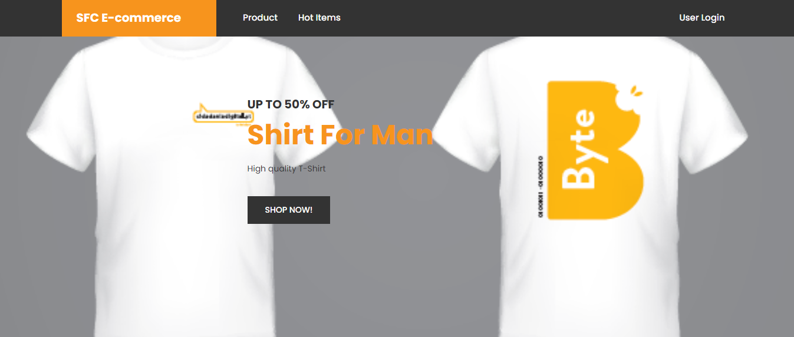

**Smart Food Choice E-commerce**

**Descriptions and functions**

The Smart Food Choice E-commerce is a system with a great help for the customers who loved shopping online. This proposed project is also secured in terms of security because system users’ passwords are encrypted.

**The main services are:**

1. The system will record every user who registers to the system.
2. The system will record the products added to cart done by the users.
3. The system will monitor the records in the database.
4. The admin can control the whole functionalities and records within the system.

**Problems Encountered**

1. Unreachable shops

**Proposed Improvements (to-be-system)**

The staff should understand computer literacy and how to function in the modern world, where technology is used for the majority of transactions, such as using the Smart Food Choice E-commerce.

**Figure 9. Usefulness in Developing SCA**

1. **Clarity Requirements –** Personal information are required to be registered to the system.
2. **Familiarity with the Technology –** The user must be computer literate enough to be able to use the system.
3. **System Complexity -** The user can use the system as long as they have an account and also should have a laptop or computer, a browser and a stable internet.
4. **System Reliability –** The Smart Food Choice E-commerce is capable of storing and securing data registered in the database.

**STAFFING PLAN**

**Project Manager**

**Technical Head**

**Functional Head**

**Analyst 2**

**Analyst 1**

**Figure 10. Staffing Plan**

|  |  |  |
| --- | --- | --- |
| **Project Manager** | Monitors the project to ensure it reaches its goals and on budget. | Alburo, Jolina S. |
| **Functional Head** | Checks that the systems suggested meet the end users’ expectations and needs. | Baril, Vicente **/** Cabahug, Ervin |
| **Technical Head** | Track the systems compliance with end users’ specification and requirements. | Quilaton, Francis John |
| **Analyst 1** | Designs the record keeping system based on the data flow. | Saladaga, Edrelyn |
| **Analyst 2** | Designs the UI of the system. | Subito, Loren |

**Table 2. Roles and Description of the system.**

**Working days: 70 Days**

|  |  |
| --- | --- |
| **STANDARD** | **ACTUAL** |
| **Planning Days** | **10 Days** |
| **Analysis Days** | **10 Days** |
| **Design Days** | **20 Days** |
| **Implementation Days** | **30 Days** |
| **Total Days** | **100 Days** |
|  |  |

**Table 3. Working Days (Project Time Frame)**

**Requirement Definition**

**Functional Requirements**

This system's functional specifications capture the anticipated behavior of the system. The system's required performance of these behaviors may be described as services, tasks, or functions. This system logs and stores all information related to internet purchases.

**Non-functional Requirements**

Non-functional requirements establish criteria that can be used to assess a system's performance in contrast to functional requirements, which define specific behavior or functions. The system should:

* Possess adequate resources, like a fast CPU, RAM, disk space, and network bandwidth.
* Possess strong performance in terms of runtime and response time.
* Stay accessible at all times
* Be dependable.
* Be able to manage several users at once.
* Be trustworthy enough for the mean time between failures to be almost nil.
* A security system that authenticates authorized users and prevents access from unwanted individuals.
* Be resilient enough to bounce back from errors or crashes.
* Have the flexibility to expand both vertically and horizontally to meet future growth without erasing current data and applications.

**Requirement Analysis Strategies**

**Problem Analysis**

Wherever we are, we cannot guarantee that we have access on malls on our places. Every time we want to buy something, we can’t because of the location of the malls. The only solution we the researchers have seen, is to create and build a Web-based system, a Smart Food Choice E-commerce Site where people can look for something or anything the user wants to buy. He/she doesn’t need to go to malls to buy but to order online for the products they want to buy. At the same time, it a great help for the users to save money from going to malls for the fares they have to pay if they don’t have private vehicles.

**Work Breakdown Structure**

|  |  |  |  |  |  |
| --- | --- | --- | --- | --- | --- |
| **Task Name** | **Start Date** | **Finish Date** | **Duration (Days)** | **Persons Involved** | **Predecessor Task** |
| **Project Planning Phase** | 04/18/22 | 04/28/22 | 10 Days | A, B, C, D, E, F |  |
| 1.1 Project Identification and Initiation | 04/18/22 | 04/19/22 | 1 Day | A, B, C, D, E, F |  |
| 1.2 System Request | 04/19/22 | 04/20/22 | 1 Day | A, B, C, D, E, F | 1.1 |
| 1.3 Feasibility Study | 04/20/22 | 04/21/22 | 1 Day | A, B, C, D, E, F | 1.2 |
| 1.3.1 Technical | 04/21/22 | 04/22/22 | 1 Day | A, B, C, D, E, F | 1.3 |
| 1.3.2 Economic | 04/22/22 | 04/23/22 | 1 Day | A, B, C, D, E, F | 1.3.1 |
| 1.3.3 Organizational | 04/23/22 | 04/24/22 | 1 Day | A, B, C, D, E, F | 1.3.2 |
| 1.4 Development Methodology | 04/24/22 | 04/25/22 | 1 Day | A, B, C, D, E, F | 1.3.3 |
| 1.5 Project Time Frame | 04/25/22 | 04/26/22 | 1 Day | A, B, C, D, E, F | 1.4 |
| 1.6 Staffing Plan | 04/26/22 | 04/27/22 | 1 Day | A, B, C, D, E, F | 1.5 |
| 1.7 Work Plan | 04/27/22 | 04/28/22 | 1 Day | A, B, C, D, E, F | 1.6 |
| **Analysis phase** | 04/28/22 | 05/08/22 | 10 Days | A, B, C, D, E, F | 1.7 |
| 2.1 Functional and Non-functional requirements | 04/28/22 | 04/29/22 | 1 Day | A, B, C, D, E, F | 2 |
| 2.1.1 Functional requirements | 04/29/22 | 05/01/22 | 1 Day | A, B, C, D, E, F | 2.1 |
| 2.1.2 Non-functional requirements | 05/01/22 | 05/03/22 | 2 Days | A, B, C, D, E, F | 2.1.1 |
| 2.2 Requirements Elicitation Techniques | 05/03/22 | 05/05/22 | 3 Days | A, B, C, D, E, F | 2.1.2 |
| 2.3 Requirement Analysis Strategies | 05/05/22 | 05/07/22 | 3 Days | A, B, C, D, E, F | 2.2 |
| **Design Phase** | 05/07/22 | 05/27/22 | 20 Days | A, B, C, D, E, F | 2.3 |
| 3.1 Design Strategy | 05/07/22 | 05/11/22 | 6 Days | A, B, C, D, E, F | 3 |
| 3.2 Design the architecture of the system | 05/11/22 | 05/15/22 | 4 Days | A, B, C, D, E, F | 3.1 |
| 3.3 Design hardware and software selections | 05/15/22 | 05/19/22 | 2 Days | A, B, C, D, E, F | 3.2 |
| 3.4 Design Database and file specification | 05/19/22 | 05/23/22 | 3 Days | A, B, C, D, E, F | 3.3 |
| 3.5 Design system navigation inputs and outpust | 05/23/22 | 05/27/22 | 5 Days | A, B, C, D, E, F | 3.4 |
| **Implementation phase** | 05/27/22 | 06/28/22 | 30 Days | A, B, C, D, E, F | 3.5 |
| 4.1 Developing the system | 05/27/22 | 05/29/22 | 3 Days | A, B, C, D, E, F | 4 |
| 4.1.1 Assigning programming tasks | 05/29/22 | 05/30/22 | 4 Day | A, B, C, D, E, F | 4.1 |
| 4.1.2 Coordinating activities | 05/30/22 | 06/01/22 | 1 Day | A, B, C, D, E, F | 4.1.1 |
| 4.1.3 Managing schedule | 06/01/22 | 06/03/22 | 3 Days | A, B, C, D, E, F | 4.1.2 |
| 4.2 Testing the system | 06/03/22 | 06/04/22 | 2 Day | A, B, C, D, E, F | 4.1.3 |
| 4.2.1 Test Planning | 06/04/22 | 06/06/22 | 1 Day | A, B, C, D, E, F | 4.2 |
| 4.2.2 Unit Test | 06/06/22 | 06/08/22 | 1 Day | A, B, C, D, E, F | 4.2.1 |
| 4.2.3 Integration Tests | 06/08/22 | 06/10/22 | 1 Day | A, B, C, D, E, F | 4.2.2 |
| 4.2.4 System Testing | 06/10/22 | 06/12/22 | 1 Day | A, B, C, D, E, F | 4.2.3 |
| 4.2.5 Acceptance Testing | 06/12/22 | 06/14/22 | 1 Day | A, B, C, D, E, F | 4.2.4 |
| 4.3 Documentation | 06/14/22 | 06/16/22 | 1 Day | A, B, C, D, E, F | 4.2.5 |
| 4.3.1 System Documentation | 06/16/22 | 06/18/22 | 1 Day | A, B, C, D, E, F | 4.3 |
| 4.3.2 User Documentation | 06/18/22 | 06/20/22 | 2 Days | A, B, C, D, E, F | 4.3.1 |
| 4.4 Operating Procedures | 06/20/22 | 06/22/22 | 2 Days | A, B, C, D, E, F | 4.3.2 |
| 4.4.1 Reference | 06/22/22 | 06/24/22 | 2 Days | A, B, C, D, E, F | 4.4 |
| 4.4.2 Procedures Manuals | 06/24/22 | 06/26/22 | 2 Days | A, B, C, D, E, F | 4.4.1 |
| 4.4.3 Tutorials | 06/26/22 | 06/28/22 | 2 Days | A, B, C, D, E, F | 4.4.2 |

**Chapter 5**

**USER INTERFACE DESIGN**

**HTML PROTOTYPE**

**PUBLIC SIDE**

**LOG-IN PAGE**

To access the system, users must log in using their personal information, such as their email address and password, on this page.

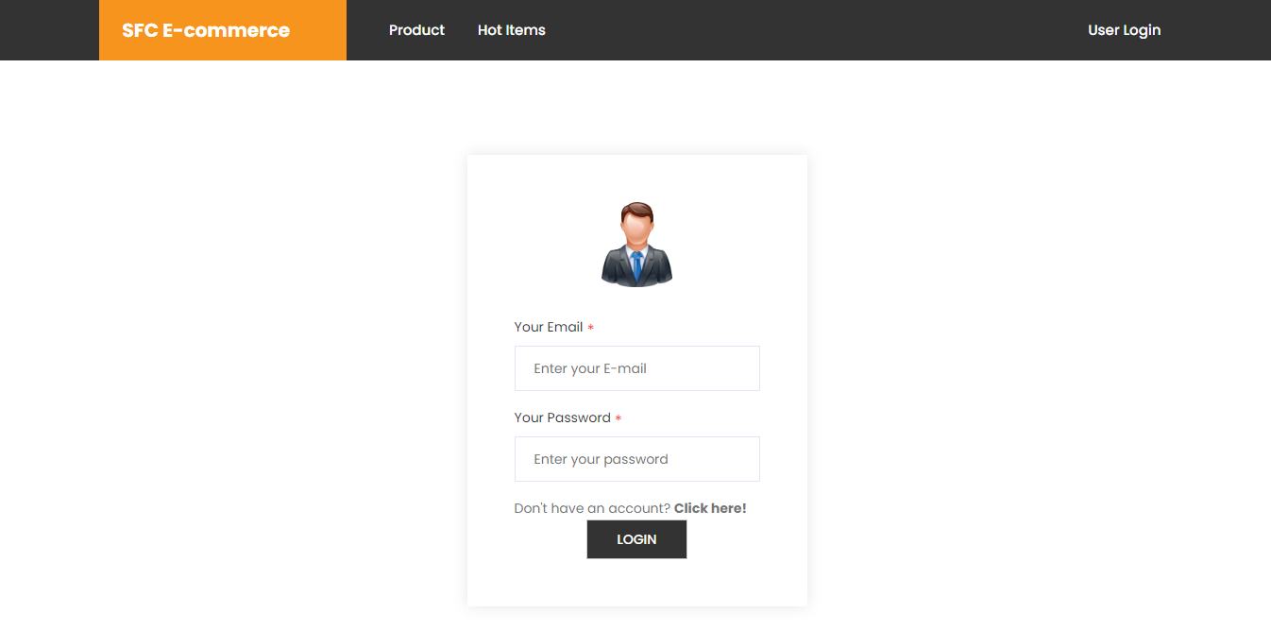

**REGISTRATION PAGE**

This page is where the users have to register their information to the system for them to be able to order online from the Smart Food Choice E-commerce.

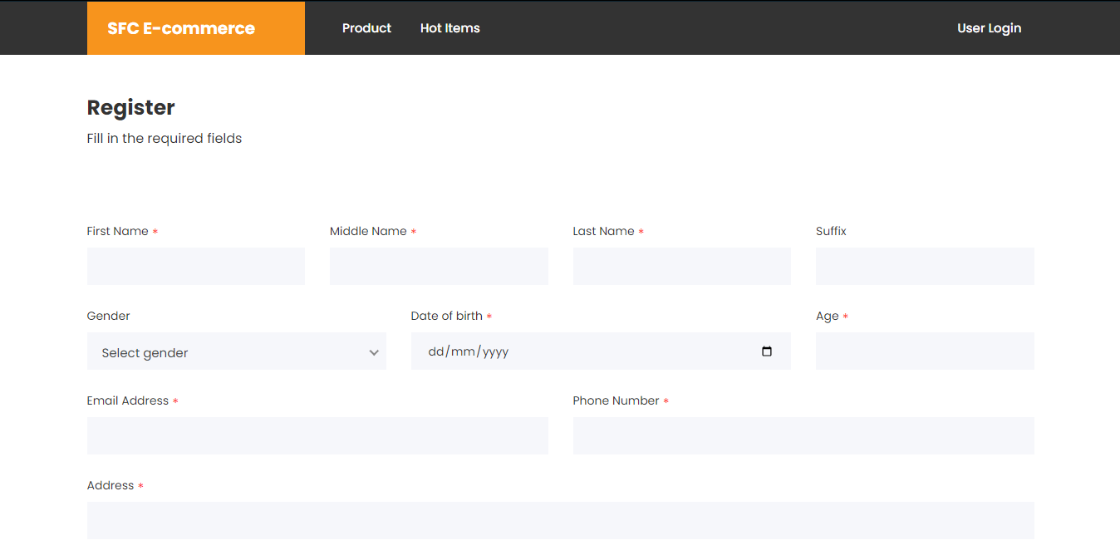

**PRODUCT LIST**

This page contains the product that are available online.

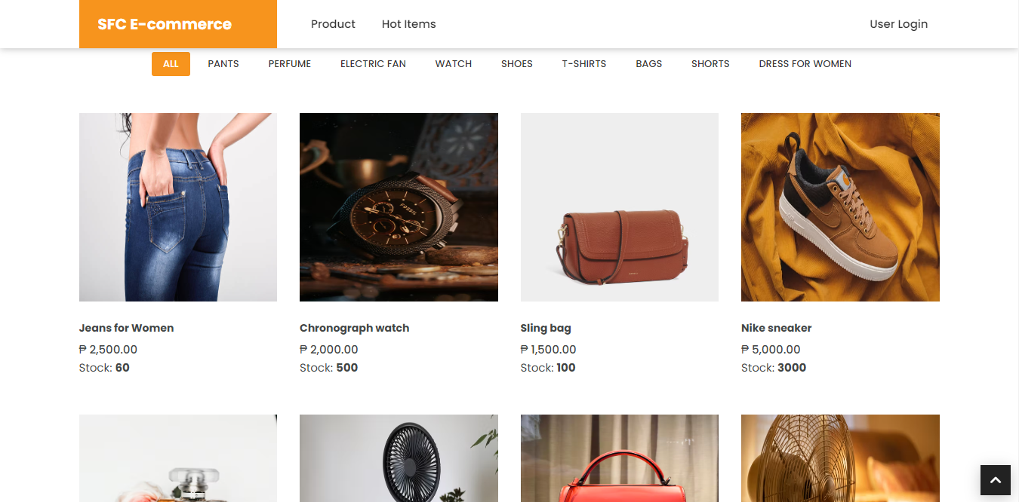

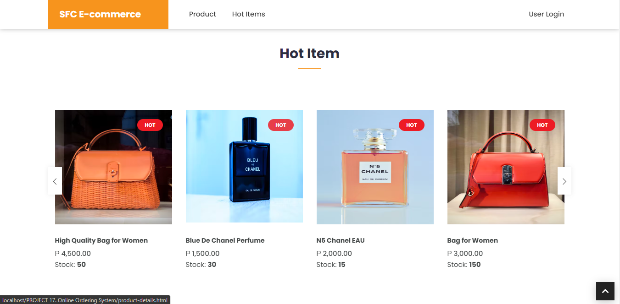

**CUSTOMER SIDE**

**CART PAGE**

This page displays the products that have been added by the user to his cart.

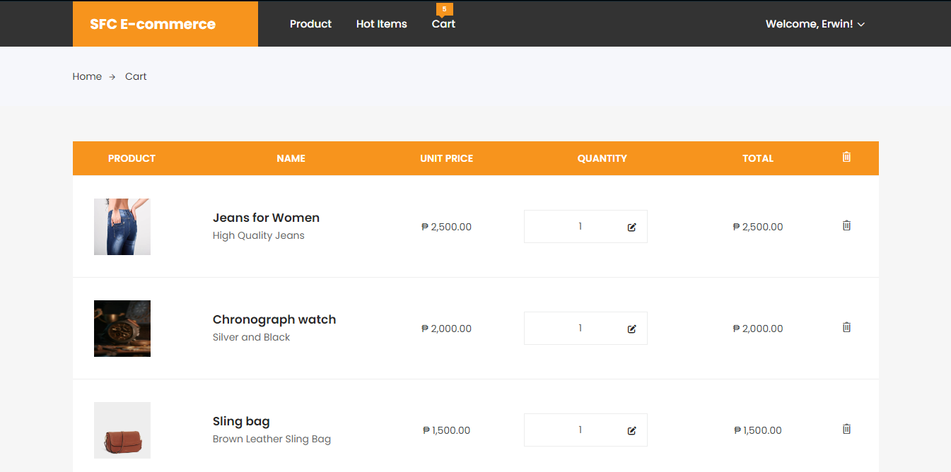

**CHECKOUT PAGE**

To display the information of the user including the total payable amount for his ordered product.

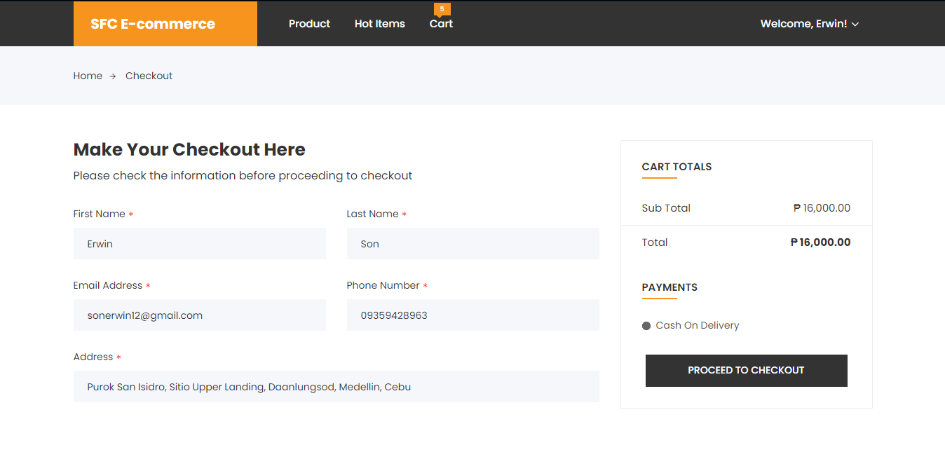

**PROFILE PAGE**

This page displays the information of the logged in user in Smart Food Choice E-commerce Site.

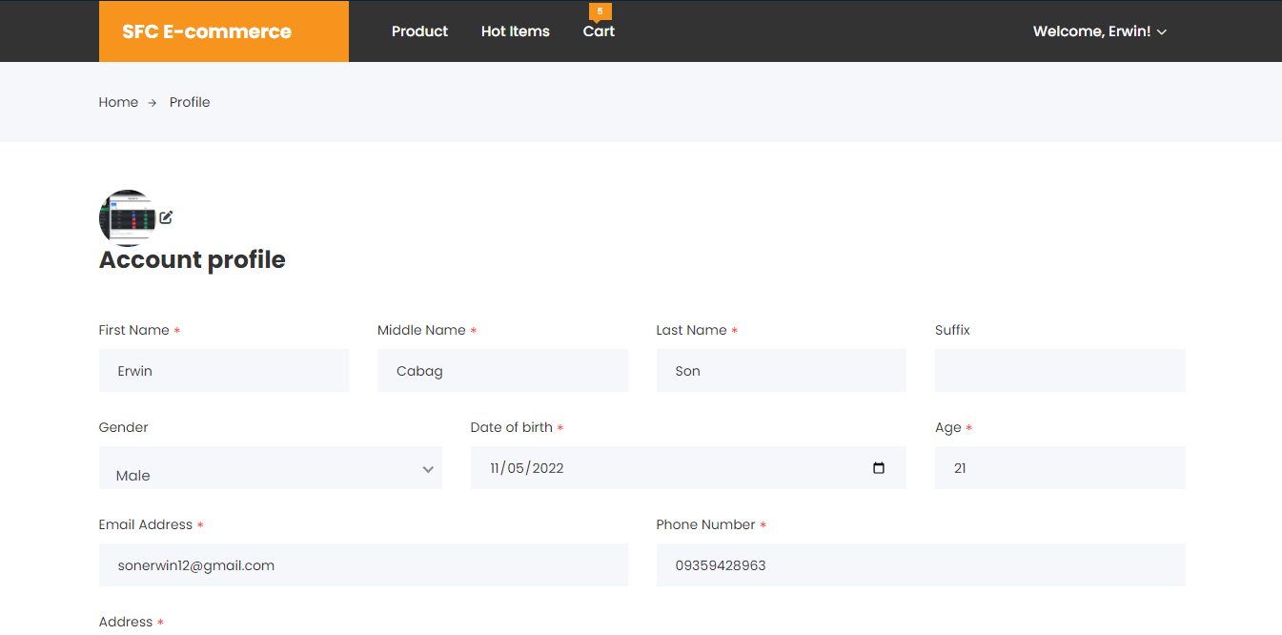

**SECURITY PAGE**

It is where the user will access if he/she wants to change his/her password.

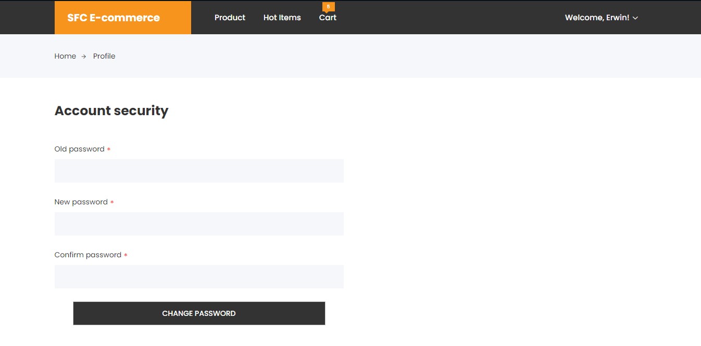

**USER LOG OUT PAGE**

This window will pop-up when the user wants to exit from the Smart Food Choice E-commerce Site.

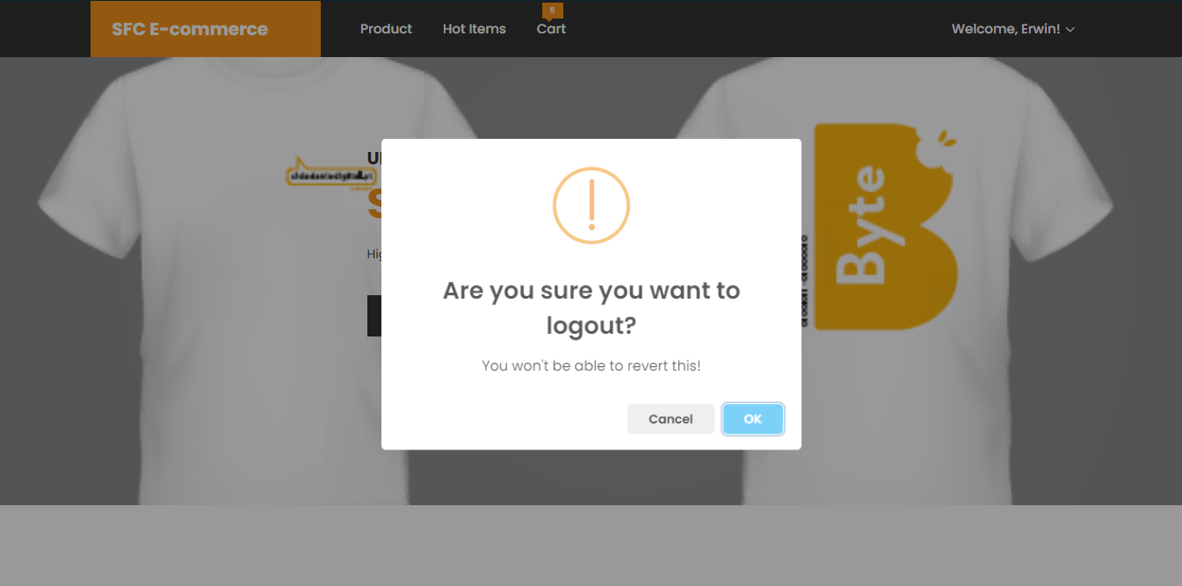

**ADMINISTRATOR SIDE**

**DASHBOARD**

The dashboard displays the number of records of the registered users and administrators of Smart Food Choice E-commerce.

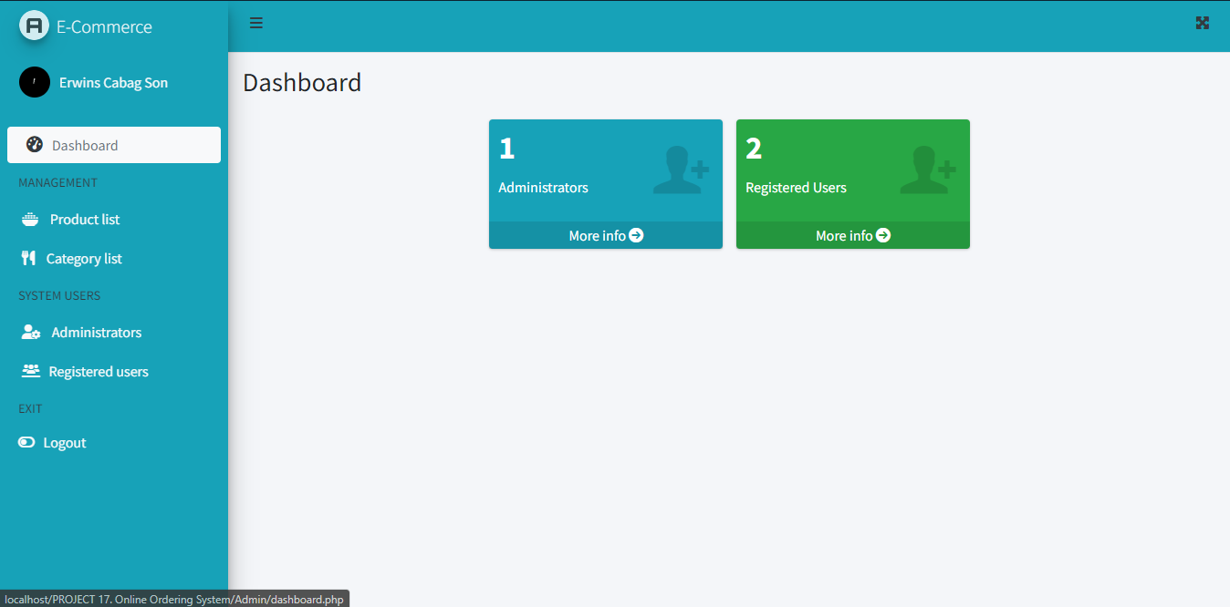

**LIST OF ADMINISTRATORS**

This is where the Administrator will see the list of administrators of the Smart Food Choice E-commerce Site.

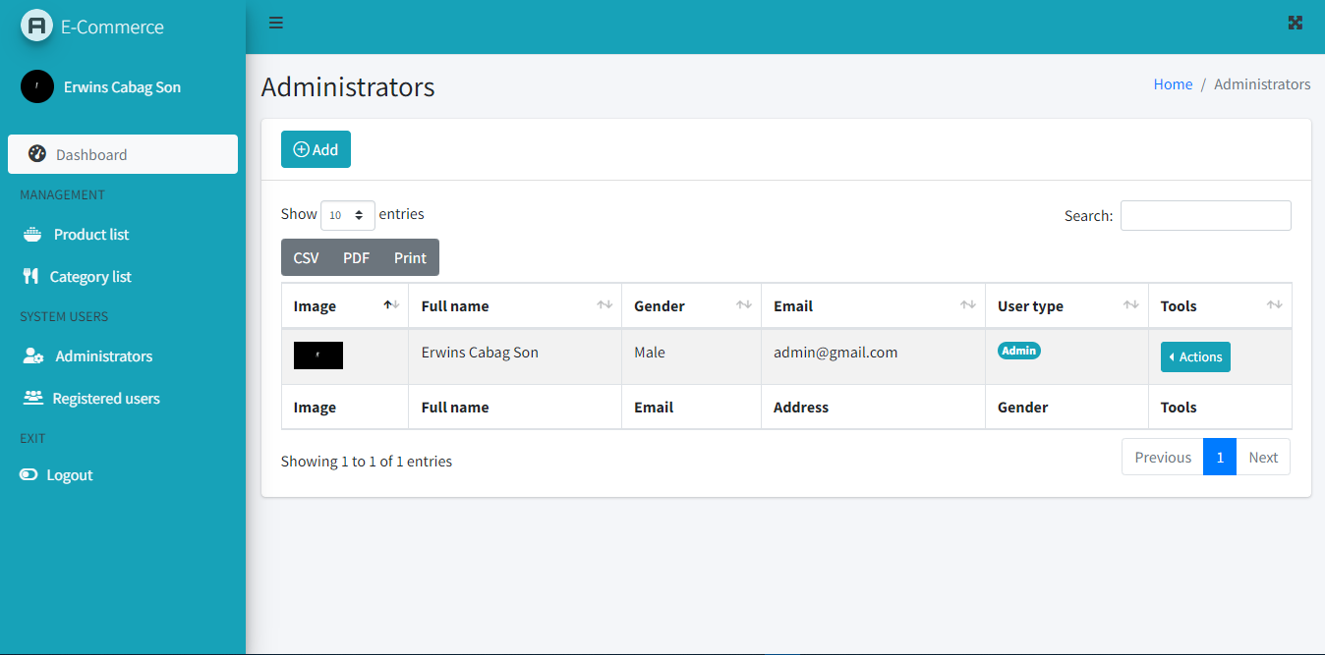

**PRODUCT LIST**

It is where the list of products are manageable.

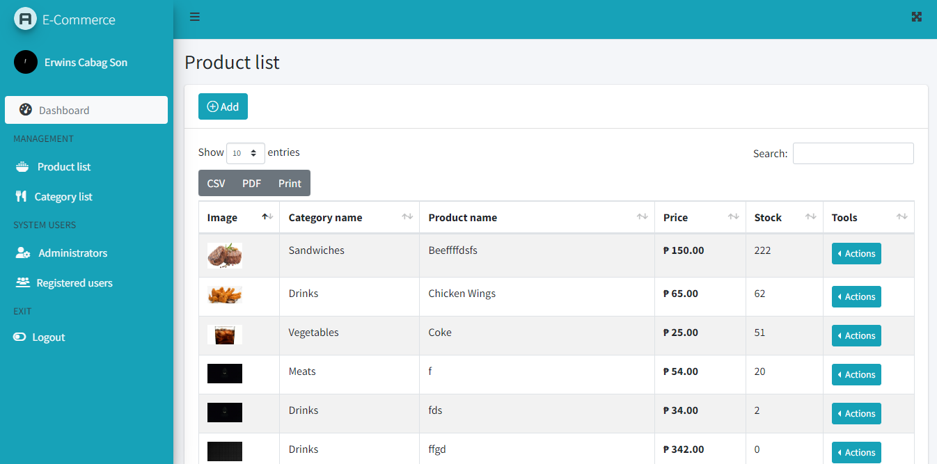

**PRODUCT CATEROGY LIST**

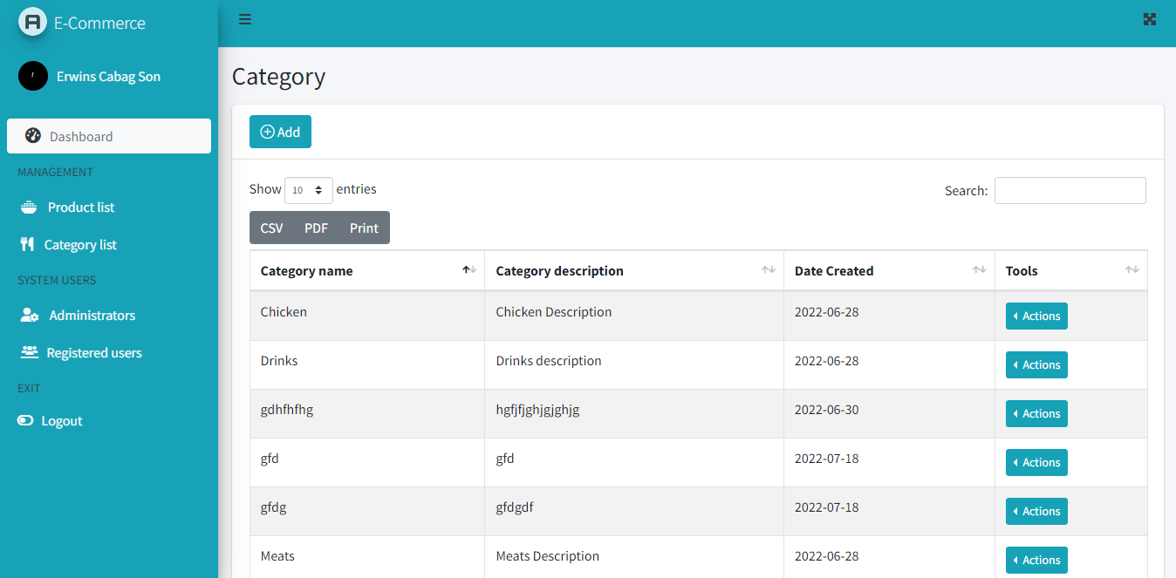 Product category list are the bases where the product should belong to a certain category. It is also manageable by the administrators.

**REGISTERED USERS**

This page displays the records of the users who register in Smart Food Choice E-commerce Site.

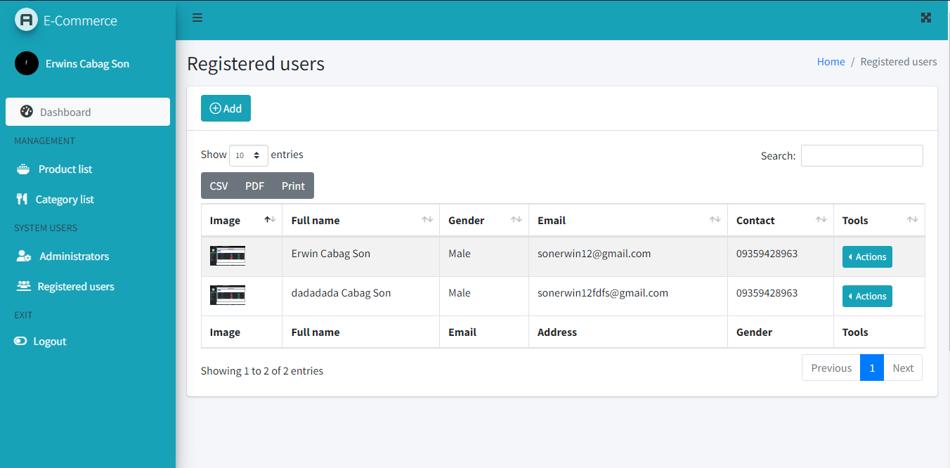

**PROFILE**

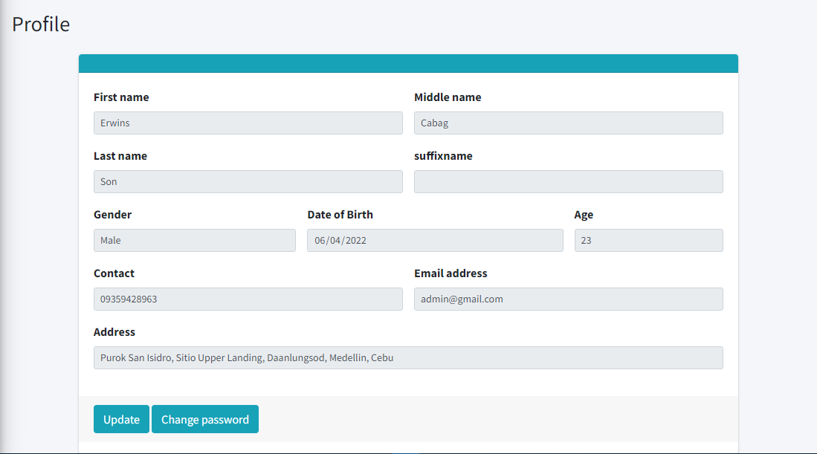This page shows the information of the logged in admin.

**CHANGE PASSWORD PAGE**

Admin can change his/her password through accessing the change password page.

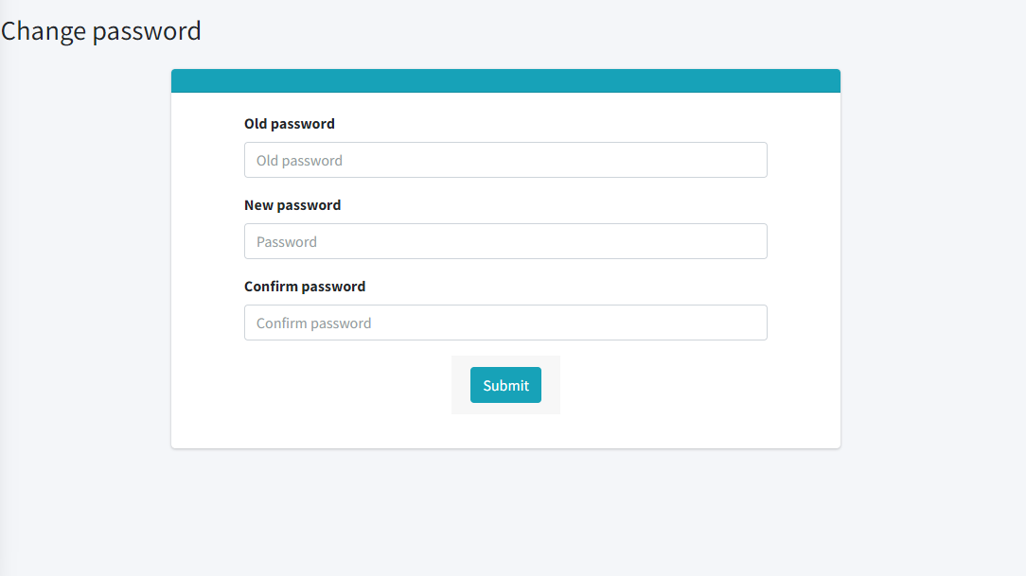

**ADMIN LOGOUT**

This system also allows users to logout their account after accessing the system.

